Microservices

**Precondition**

**Participants must have good Knowledge on basic microservices**

Total Duration: 5 Days

Day 1

* Banking POC discussion
* Spring Boot End point customization (Hands on)
* Wire Mock Api testing (Hands on)
* API design Best Practices
* Swagger Documentation (Hands on)
* Naming conventions
* Filtering Flexibility using Graphql, Squiggly, RSQL Visitor (Hands on)
* Paging and Sorting (Hands on)
* Versioning (Hands on)
* HTTP Status Codes (Hands on)
* Stability and Consistency (Hands on)
* Security using OAUth2 and JWT (Hands on)

Day 2

Microservices Design

• Microservice Architecture Decisions

• Microservice Design Patterns

o High Cohesion

o Loosely coupled

o Adapter pattern

o Chain Pattern

o Shared Resource Pattern

• Microservices Composition Pattern

• Microservice Security Principles/Techniques

• Ownership and Versioning

• Domain Centric

• Centralized Monitoring

Domain Driven Design

* Strategic Design Tools
* Tactical Design Tools
* Problem Space
* Solution Space
* Sub Domains
* Bounded Context
* Ubiquitous Language
* Context Map
* Model Driven Design
* Entities
* Repositories
* Services
* Aggregators
* Factory
* Value Objects
* Best Practices in Code Implementation

Design Patterns in Microservices

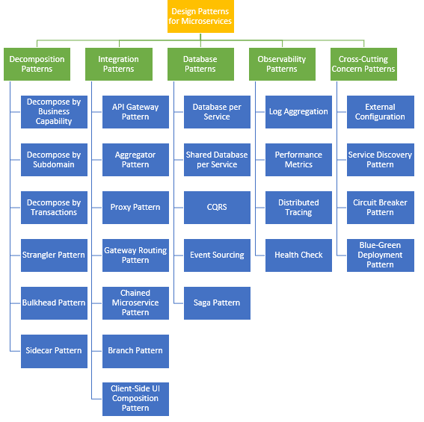

Day 3

**Spring Cloud**

* Vault Server **(Hands on)**
* Cloud Bus **(Hands on)**

[**Building Data Processing Pipelines Out of Microservices**](https://app.pluralsight.com/player?course=java-microservices-spring-cloud-coordinating-services&author=richard-seroter&name=18412e5c-f352-4c68-b927-09d077a9ebba&clip=0&mode=live) **(Hands on)**

* Building Data Processing Pipelines Out of Microservices
* The Role of Orchestration and the Problem with the Status Quo
* About Spring Cloud Data Flow
* About the Data Flow Server
* Consider Streams vs. Tasks
* Installing Spring Cloud Data Flow
* Getting Spring Cloud Data Flow up and Running

[**Building Data Processing Pipelines Out of Micro services**](https://app.pluralsight.com/player?course=java-microservices-spring-cloud-coordinating-services&author=richard-seroter&name=18412e5c-f352-4c68-b927-09d077a9ebba&clip=0&mode=live) **(Hands on)**

* About Stream Starter Apps
* Creating Streams with Spring Cloud Data Flow
* Deploying Data Pipelines
* Creating Tasks with Spring Cloud Data Flow
* Using the Spring Cloud Data Flow Dashboard and Flo
* Building, Deploying, and Tapping Streams from the Dashboard
* Creating Custom Stream or Task Apps
* Creating, Registering, Using, and Partitioning Custom Apps
* Creating Composed Tasks
* Creating Custom Task Apps and Arranging in a Composed Task
* Monitoring Spring Cloud Data Flow Pipelines
* Updating Apps, Streams, and Tasks

CQRS Pattern using Axon Framework (Hands on)

Saga Pattern Event Driven using Kafka and Zoo keeper **(Hands on)**

**Moving Forward with Microservices**

**• Migration to Microservices**

**• Microservices Transaction Management**

**• Microservices Database Migration**

**• Microservices Reporting**

**• Integrate with Application Performance Metrics tools such as**

**o AppDynamics**

**o Splunk and**

**o Other tools such as Kibana, ELK search.**

**ESB using Mulesoft**

Day 4

**Business Process Management Basics**

**Introduction to Camunda BPM**

**BPM & Process Automation**

* Process Modeling with BPMN 2.0
* Process Automation with BPMN 2.0
* Case Management with CMMN 1.0
* Toolchain and methodology
* Patterns and Best Practices
* Components Overview

**Administration**

**Installing Camunda BPM**

* Integration into existing application server
* Database setup
* Sizing the production environment
* Clustering
* Performance tuning possibilities

**Operations**

* Monitoring the engine
* Integration into alarming (e.g. Nagios)

**Upgrades**

* Release strategy
* Hotfixes
* Major releases
* Migration support

# **DMN Training** (Hands on)

* Introduction into Decision Model & Notation, and Decision Tables
* Expressions with FEEL
* Hit Policies and Decision Design
* Decision Execution and Decision Engines
* DMN in the context of BPMN
* Complex Decisions with Decision Requirements Diagrams

Decision Flows

Day 5

# **Camunda BPM and Microservices** (Hands on)

* Process Modeling with BPMN 2.0
* Camunda BPM Platform
* Deploying to Camunda Engine
* Work with External Service Tasks
* Data Objects, Gateways & Expressions
* BPMN Event Handling
* Incident Handling
* Error Handling and Compensation
* Human Task Management
* Process Interaction
* Architecture
* Decoupling with Events
* Testing Processes
* Business Rules with DMN
* Camunda BPM Enterprise Edition
* Wrap up

**Process Engine**

* Shared vs. embedded Process Engine
* Process, Subprocess
* Deployment Scenarios
* Programming Model using CDI or Spring
* Process Data (Variables, XML, JSON) and Expression Language (JUEL, XPath)